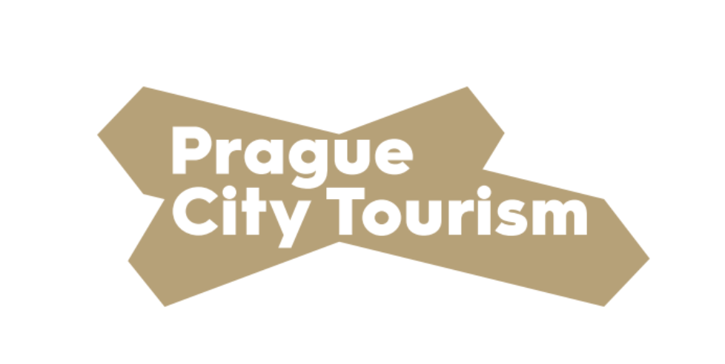

Press Release

In the period from April to June, Prague experienced more than a 90% decline in tourism.
Prague, 7 August 2020 - According to data from the Czech Statistical Office (CSO), only 138,187 visitors came to Prague in the second quarter of this year. This is a decrease of more than 93% compared to the same period in 2019. This clearly reflects the impact of the covid-19 pandemic.
"Unfortunately, current data from the Czech Statistical Office confirm the most pessimistic scenarios of the impact of the coronavirus crisis on tourism in Prague. However, the measures we have taken to support tourism on behalf of the capital are as successful as possible and they manage to motivate domestic tourists to visit Prague. They at least partially dampen this drastic decline,” says Hana Třeštíková, Councilor for Culture and Tourism of the City of Prague.
As the CSO data show, the length of overnight stays was shortened by 0.4 nights during this period compared to last year's data. Tourists spent an average of 1.9 nights in Prague.
As for the nationality composition of foreign visitors, according to the assumptions, Prague was visited most by people from neighboring countries. In the long run, people from Germany are heading to the Prague metropolis the most. This trend continues even with post-coronavirus measures. 92,457 domestic guests visited the capital, a decrease of 70.6% compared to 2019.
In order to mitigate the effects of coronavirus and restart tourism in Prague, the City of Prague, together with Prague City Tourism, launched the At Home in Prague campaign in mid-June. For example, the president of the Czech Confederation of Commerce and Tourism, Tomáš Prouza, estimates that thanks to this campaign, the decline of the entire sector will be about a quarter smaller.
Last but not least, representatives of Prague City Tourism mention the fact that tourism now targets mainly domestic and cross-border tourists. Visitors from the United States and Asian countries, such as China and South Korea, are not expected until next year at the earliest.
Media Contact:
Klára Malá, Spokesperson of Prague City Tourism, phone: +420 777 355 999

