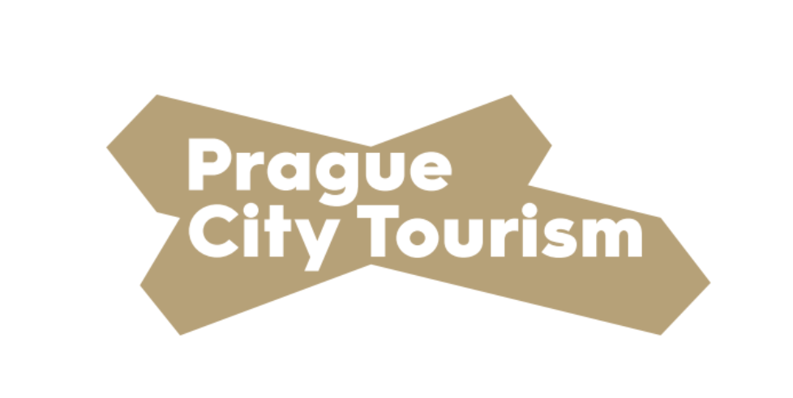

Press Release

The successful summer of the At Home in Prague campaign decided to extend it's duration until the end of this year.
Prague, September 17, 2020 - Thanks to the At Home in Prague campaign, almost 60,000 people came to the metropolis in the summer, mainly from the Czech Republic, Germany, Austria and Slovakia. Feedback on the campaign is very positive. The capital, together with Prague City Tourism, will extend the duration of At Home in Prague until the end of December this year.
Extension of the campaign's duration is possible thanks to a large number of benefits and a well-set system. It will also support pre-Christmas tourism and prepare special Christmas offers. According to representatives of Prague City Tourism, visitors had a large number of benefits and free tickets. However, they were not all used and thus have been returned to circulation for possible further use. The campaign can thus operate for three months longer than originally planned.
"The capital supported the restart of tourism with the amount of 120 million Czech crowns. I will be very pleased if, thanks to the duration extension of the At Home in Prague campaign, these funds will be used to the last crown and thus help entrepreneurs in the field of tourism and at the same time make Prague visitors' stay in the capital more pleasant,” says Hana Třeštíková, Councilor for Culture and Tourism.
More than 400 accommodation facilities have joined the campaign, and visitors can use free tickets to almost eighty tourist attractions, such as museums, galleries or individual Prague monuments. During the summer, tourists most often went to the Prague Zoo, Prague Castle or Petřín Lookout Tower.
"Of course, we will not be able to reach the state of tourism as it was in 2019, ie before the crisis associated with the pandemic. However, I must say that the feedback from visitors and some hotels, whose room occupancy rate increased by several tens of percent, motivates us to extend the duration of the campaign," says František Cipro, Chairman of the Board of Prague City Tourism.
All information about the campaign can be found on the website pragueunlocked.eu
Media Contact:
Klára Malá, Spokesperson of Prague City Tourism, phone: +420 777 355 999

